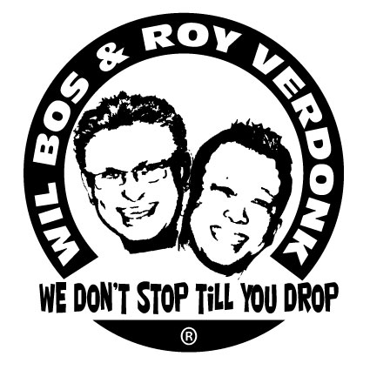
Twist with the Fat Boys

Choreographers : Roy Verdonk & Wil Bos
Level : Intermediate

Dance : Phrased A-B A = 48 counts, B = 32 counts
Music : Fat Boys & Chubby Checker - The Twist
Intro : 16 counts (start counting after the word “twist”)
Note : Sequence – ABB-ABB-ABB-AB-A-A-A till end

Part A

Pulp Vision With Heel Bounces, Sailor Step R, Sailor Step L
1-2-3-4 Move right hand from left to right in front of eyes to right while you bounce your right heel
5&6 Cross RF behind LF, Step LF to left side, Step RF to right side
7&8 Cross LF behind RF, Step RF to right side, Step LF next to RF

Heel Toe Swivel ( x3), Clap, Toe Strut R, Toe Strut L
1-2-3-4 Swivel heels left, Swivels toes left, Swivel heels left, Clap
5-6 Step forward on right toes, Step down on right heel
7-8 Step forward on left toes, Step down on left heel

Step Forward R, ½ Turn L, Step Forward R, ½ turn L, Stomp forward R, Swivel L Heel, Toe, Heel,
1-2 Step RF forward, ½ Turn left
3-4 Step RF forward, ½ Turn left
5-6-7-8 Stomp RF forward, Swivel heel LF inwards RF, Swivel toes LF inwards RF, Swivel heel LF inwards RF

Out L, Out R With Clap, In R, In L with Clap, Stomp Forward R, Bounce L and R ¼ turn L with Chicken Head!
&1-2 Jump out forward RF, Jump out forward LF Left ( feet shoulder width apart ), Clap hands
&3-4 Jump in back RF, Jump in back LF (feet together), clap hands
5-6-7-8 Stomp RF forward, Bounce on both heels ¼ turn left while nod head forward, back

Cross R, Point L, Cross L, Point R, Close, Stomp Forward L, Hold( for 3 counts)
1-2 Cross RF over LF, Point toes LF to the left side
3-4 Cross LF over RF, Point toes RF to the right side
&5 Close RF next to LF, Stomp LF forward,
6-7-8 Hold for 3 counts

Close L, Step R, ½ Turn Left in 7 counts and walk with wobbling knees!
&-1 LF beside RF, Step RF forward,
2-8 Walk in seven counts a ½ turn left, and push your knees in and out.(weight ends on LF)

Part B

Step R with Hip Bump R x2, Step L with Hip Bumb left x2, Hip Roll anti clockwise
1-2 Step RF to the right side and Bump right hip to the right x 2
3-4 Bump left hip to left side (x2)
5-6-7-8 Roll your hips in a circle 2 times anti clockwise

Rolling Vine R, Clap, Rolling Vine L, Clap
1-2 ¼ turn right step RF forward, ½ right step LF back
3-4 ¼ turn right step RF to right side, Clap hands
5-6 ¼ turn left step LF forward, ½ turn left step back on RF
7-8 ¼ turn left step LF to left side, Clap hands

Slow Diagonal Right Shuffle Forward, Hold, Slow Diagonal Left Shuffle Forward, Hold
1-2-3-4 Step RF forward to right diagonal, Close LF next to RF, Step RF forward to right diagonal, Hold
5-6-7-8 Step LF forward to left diagonal, Close RF next to LF, Step LF forward to left diagonal, Hold
Hand movements; On count 1-3-5-7 when you step forward use your hands like pulling yourself forward

Jazz Box Cross ¼ Turn R, Diagonal Hand Push Forward with Hip Bumb Backwards(x2)
1-2 Cross RF over LF, ¼ right step back on LF
3-4-& Step RF to right side, Cross LF over RF, Step RF to the right side.
5 Push both hands left forward diagonal while you push your bum backwards right
(stretch knees R & L backwards)
6 Recover RF & LF center
&-7 take weight on left Push both hands right forward diagonal while your bum backwards left
(stretch knees R & L backwards)
8 Recover RF & LF center

Start again smile and have fun

